Deepika AG
MySQL Assignment 2 – Querying Data

- Distinct Values:

a query to retrieve distinct salaries from the Employees table.

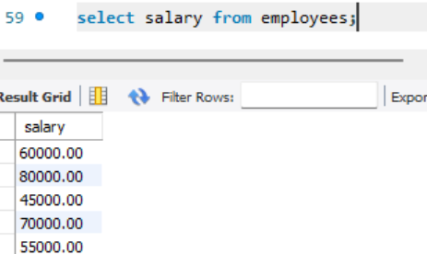

2. Alias (AS):
Provide aliases for the "age" and "salary" columns as "Employee_Age" and "Employee_Salary", respectively.

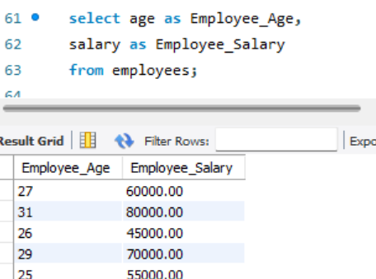

- Where Clause & Operators:
Retrieve employees with a salary greater than ₹50000 and hired before 2016-01-01.

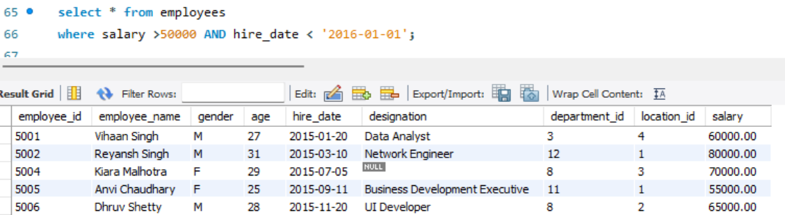

Find the employee whose designation is missing and fill it with "Data Scientist".

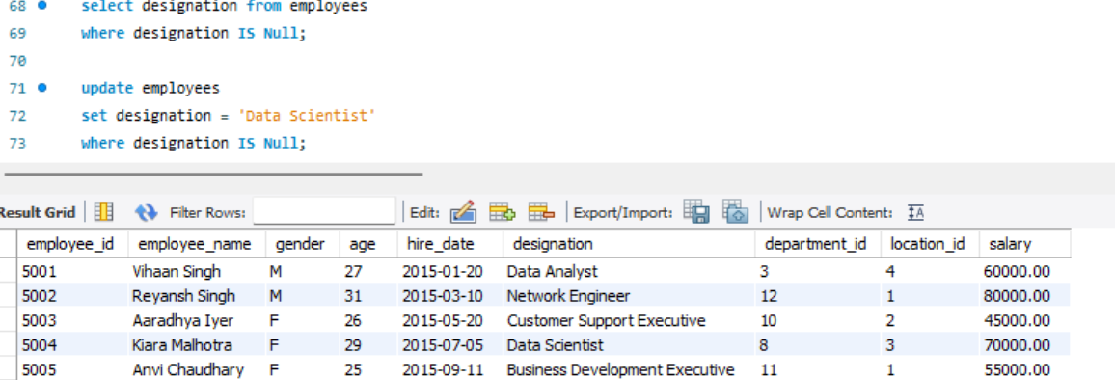

Sorting and Grouping Data:

- ORDER BY:

Find employees sorted by department ID in ascending order and salary in descending order.

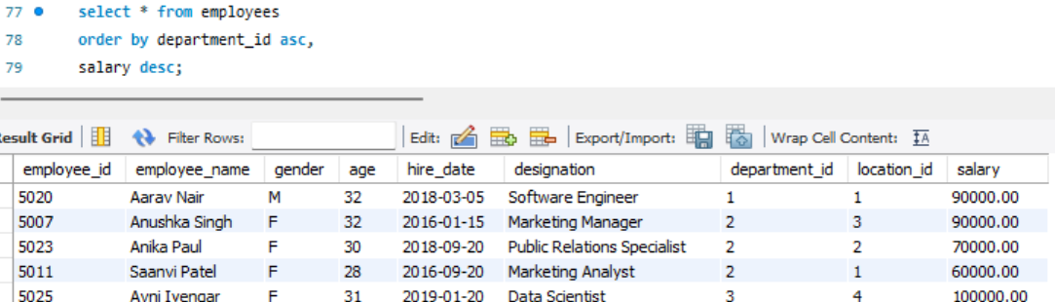

- LIMIT:

Display the first 5 employees hired in the year 2018.

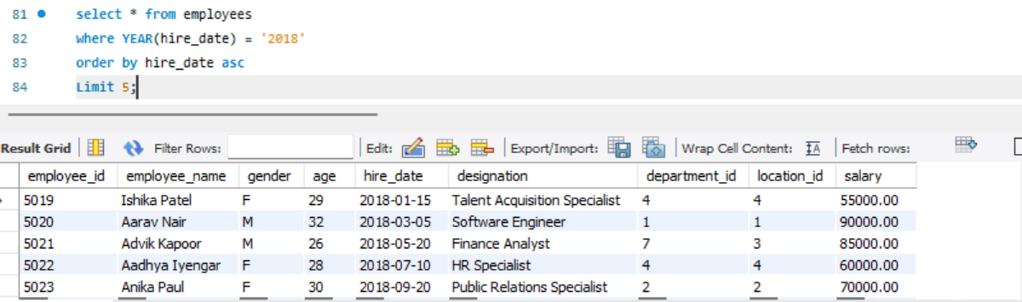

- Aggregate Functions:
Calculate the sum of all salaries in the Finance department.
I used to methods as below.
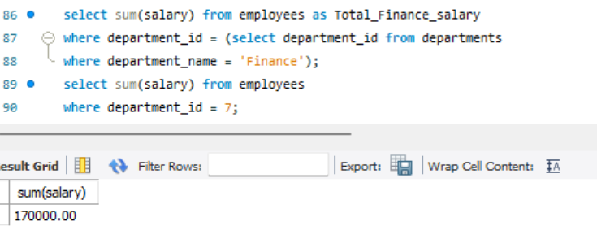

Find the minimum age among all employees.

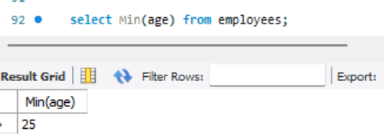

- GROUP BY:
List the maximum salary for each location.

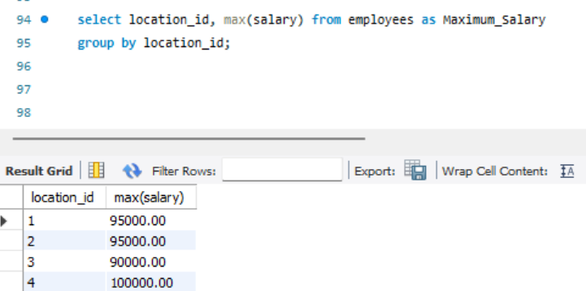

- HAVING:

Find departments with less than 3 employees.

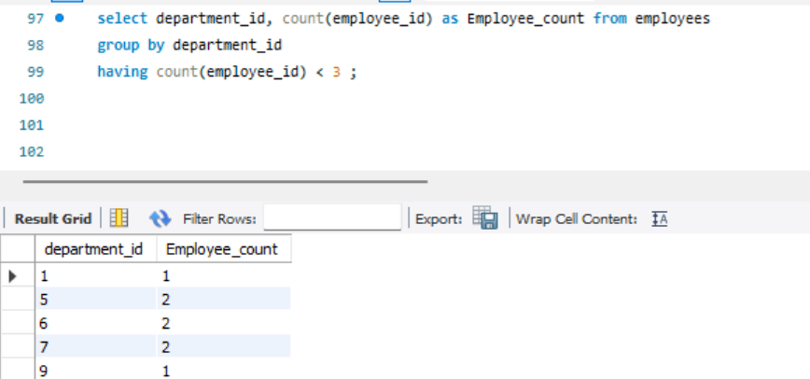

Find locations with female employees whose average age is below 30.

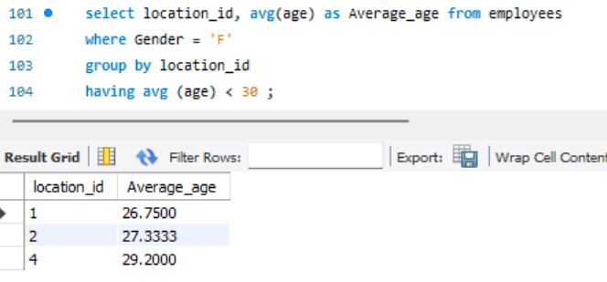

- Inner Join:
List employee names, their designations, and department names where employees are assigned to a
department.

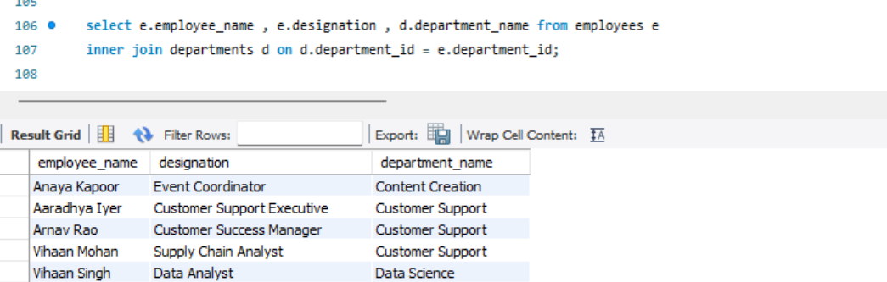

List all departments along with the total number of employees in each department, including departments
with no employees.

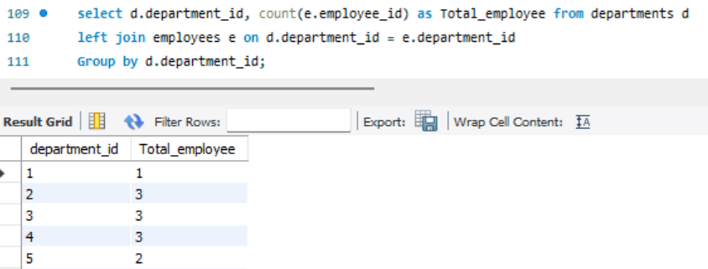

Display all locations along with the names of employees assigned to each location. If no employees are assigned
to a location, display NULL for employee name.

